Quantum Cryptography: Principles, Protocols, and Applications
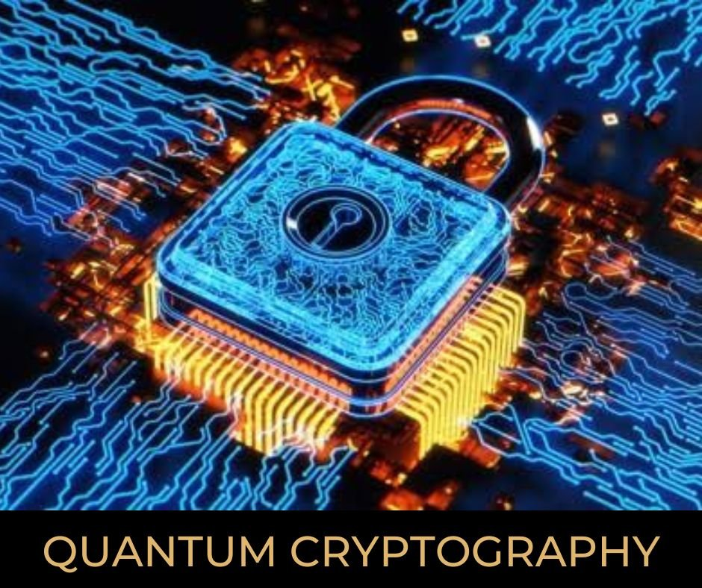

Abstract
Quantum cryptography represents a groundbreaking advancement in secure communication, rooted in the principles of quantum mechanics. It primarily revolves around Quantum Key Distribution (QKD), a technique that allows two parties to exchange encryption keys with security guaranteed not by computational assumptions, but by the laws of physics. This paper explores the fundamental concepts of quantum cryptography, including the theoretical underpinnings of superposition, entanglement, and the no-cloning theorem. It examines major QKD protocols such as BB84 and E91, reviews real-world applications and commercial implementations, and analyses the current technological infrastructure supporting quantum communication. Furthermore, it discusses the key challenges in deployment and the future prospects of global quantum-secure networks. By addressing both the theoretical and practical aspects, this paper provides a comprehensive overview of the current state and potential of quantum cryptography.

Introduction
Cryptography has played a vital role in securing communication for centuries, evolving from simple ciphers to complex mathematical encryption methods. Traditional cryptographic systems rely on mathematical complexity to ensure security, but advances in computing power have made many of these methods vulnerable to decryption. The emergence of quantum cryptography introduces a revolutionary approach by leveraging the principles of quantum mechanics to enhance security. Unlike classical cryptographic techniques, quantum cryptography utilizes individual photons and Heisenberg’s uncertainty principle to detect eavesdropping attempts, ensuring unbreakable encryption.
Historically, cryptographic advancements have been driven by the need for secure communication, particularly in military and diplomatic contexts. From early cipher techniques to the unbreakable one-time pad and the development of public-key cryptography, each innovation has addressed the growing challenges of secrecy and computational efficiency. However, the limitations of classical encryption, especially against powerful adversaries with advanced computing capabilities, highlight the need for more robust security measures.
Quantum cryptography represents a paradigm shift by providing a theoretically unbreakable method of secure communication. By utilizing the fundamental properties of quantum mechanics, such as superposition and entanglement, quantum cryptographic protocols offer unprecedented levels of security. This research explores the principles, applications, and future potential of quantum cryptography in safeguarding digital communication against emerging threats.
Encryption is the process of hiding information in many meaningless bits for unauthorized parties. It involves combining messages with additional confidential information, such as Alice and Bob, to ensure the message remains protected. Public key systems, such as RSA, are popular over the past 20 years but face challenges in factorization.
Known algorithms can improve the safety of RSA by selecting a longer key, but there is no guarantee that such an algorithm exists. Quantum computers, which have advanced in theory, may eventually replace RSA. Private key cryptosystems, such as the Data Encryption Standard (1977), use code and decoding using the same algorithm as the 56-bit key.
Cryptographic confidentiality proposed by Burnham in 1935 allows messages to be encrypted using random keys of the same length, adding all the bits to the corresponding bits of the key. This system is secure, but requires sharing a common private key, which can be complex and expensive. Brassard 1984 introduced Quantum Key Distribution (QC), which allows two physically separate parties to create random private keys without checking whether the key is being intercepted.
Quantum systems are a single photon spread across an optical fibre, and keys can be encoded by polarization or its phase. The first experimental demonstration of quantum cryptography was made in 1989 with polarizers above 30 cm of air. QC systems have technical limitations, and their transmission distance and bit rate are evaluated in this article.

Table 1: Comparative Analysis: Classical Cryptography vs Quantum Cryptography
Aspect | Classical Cryptography | Quantum Cryptography
Security Basis | Based on computational hardness (e.g., factoring, discrete logarithms) | Based on laws of quantum mechanics (e.g., superposition, no-cloning)
Vulnerability to Quantum Computers | Vulnerable (e.g., RSA, ECC can be broken using Shor’s algorithm) | Secure (QKD protocols like BB84 are immune to quantum computing attacks)
Eavesdropping Detection | Not inherently supported | Built-in: any interception disturbs the quantum state and can be detected
Key Distribution | Centralized (via CAs, KDCs) or static | Peer-to-peer, real-time key generation via quantum channels
Key Freshness | Static or requires manual/key lifecycle management | Dynamic, fresh keys generated per session
Forward Secrecy | Optional, implementation dependent | Intrinsic to QKD (keys are ephemeral and not reused)
Provable Security | Based on unproven assumptions | Information-theoretic security (mathematically and physically provable)
Side-Channel Attack Resistance | Vulnerable (e.g., through timing, power, electromagnetic analysis) | Strong resistance, especially in MDI-QKD systems
Dependence on Trusted Parties | Requires trusted third parties (e.g., certificate authorities) | Operates independently; trust is built on quantum physics
Long-Term Viability | Requires frequent algorithm upgrades and longer key lengths | Future-proof with physics-based protection, no need for algorithm changes
Deployment Readiness | Mature and globally deployed | Emerging and rapidly progressing, with successful prototypes and testbeds worldwide
Scalability | Highly scalable over digital networks | Limited by quantum channel distance and current hardware limitations
Implementation Cost (currently) | Low to moderate (widely adopted and optimized) | High (specialized hardware like photon sources, detectors, and quantum channels required)

Literature Review
Quantum cryptography — This is entirely revolutionary for sure as it uses quantum mechanics to secure the information being transmitted over here. BB84, by Charles Bennett and Gilles Brassard in 1984 is the first and most central Quantum Key Distribution (QKD) protocol among several quantum cryptographic protocols. BB84 protocol is the widely studied Quantum Cryptography protocol in which 2 parties or Alice, Bob (generally) to establish a shared secret key from an unwanted third party over an insecure channel providing quantum physics law-based security. Cryptography other than classical, which is based on computational assumption — BB84 is provably secure against any computational attack, and in particular that by quantum computers.
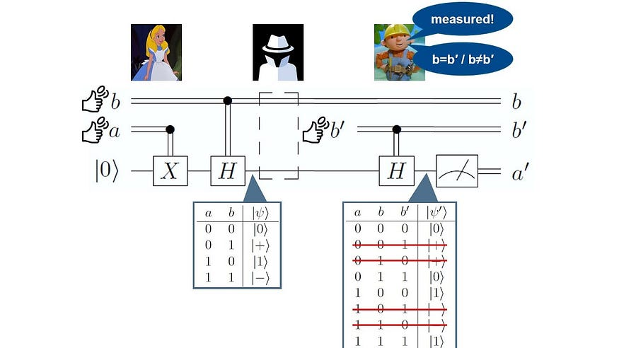
How it works?
Alice and Bob are connected to the quantum canal via classic public channels, where individual photons are used to carry information. Alice sends photons in four polarized states, and Bob accidentally votes and records her choice. Bob has two analysers that distinguish between horizontal and vertical polarizers and +45 & -45 photons. Bob records the analyser used and the results. Alice compares this sequence with a list of compatible polarization states and bits transmitted by photons using an analyser by sending a bob.
If an incompatible condition and an analyser is used, the bit is rejected. When listening interrupts bit exchange, the correlation between the bit values ​​decreases. In 50% of cases, Alice chooses the wrong analyser, transmits polarized light with a false base, leading to an incorrect number of Bobs.
In reality, there are transmission and standard errors. Error rates must be entirely attributable to EVE, and data protection reinforcements can be used to reduce the corresponding information. The remaining keys can now be used by Total Trust to encrypt messages.
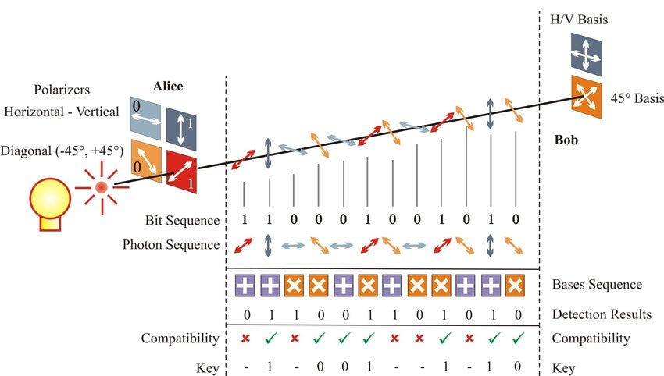

- Alice Generates a Random Bit String
  - Alice creates a random sequence of bits (0s and 1s).
- Alice Assigns Random Bases
  - Each bit is encoded in either the Rectilinear (+) basis or Diagonal (×) basis randomly.
  - For Example:
Bits: 1 0 1 1 0 0 1 0
Bases: × + × × + × + +
- Alice Sends Polarized Photons to Bob
  - Each bit is sent as a photon with a specific polarization, based on the chosen basis.
  - The qubits travel through a quantum channel (fibre optics or free space).
- Bob Measures the Incoming Qubits
  - Bob randomly picks a basis (+ or ×) for each photon.
  - If he chooses the correct basis, he gets the right bit.
  - If he chooses the wrong basis, the measurement is random.
  - Example:
Bases: + × × + + × × +
- Public Basis Comparison
- Alice and Bob publicly announce their bases that they had chosen (but NOT the bits).
- They retain only the parts where their bases aligned and ignore the rest.
- Example: Matched positions: 3, 5, 6, 8. These bits form the raw key.
- Eavesdropper (Eve) Detection
- If Eve measures and intercepts the qubits, quantum mechanics disturbs their state to introduce errors.
- Alice and Bob each publicly share a small of their key to test for errors.
- They abort the process if errors are above some threshold.
- Final Secret Key
- Alice and Bob discard mismatched bits, remove non verified bits, and are left with a shared secret key.
- This key can now be used for encryption in secure communication.

Security and Error Handling in BB84
Quantum mechanical core such as no-cloning theorem and measurement disturbance are enough to robust quantum cryptography protocols like BB84 of the core features of quantum mechanics. Such rules are designed to ensure that eavesdropping will necessarily reveal non-classical behaviour in the key exchange. Photon loss, detector inefficiencies, environment noise and misaligned optical components are some sources of error in quantum communication QBER (Quantum Bit Error Rate) threshold is near 11%.
Quantum mechanics says that Eve's measurements always disturb the photon's quantum state leading Alice and Bob's bit strings to differ Only if the error rate is below threshold, are the remaining bits considered secure using error-correction strategies like taking out a sample of bits for error detection. The bit sequences sent by Alice and Bob are not in sync, for which error correction using Window Protocol, LDPC Codes and the Cascade Protocol are applied. Eve knows almost nothing as a result of privacy amplification, providing provably secure final key in strictly worst-case scenarios.
Table 2: Key Security Mechanisms in QKD
Component | Purpose | Techniques Used
Quantum Bit Error Rate | Measures noise and possible eavesdropping | Sample comparison (threshold ~11%)
Error Correction | Align Alice and Bob’s raw keys | Cascade, LDPC, Winnow
Privacy Amplification | Remove Eve’s partial knowledge | Hashing, entropy reduction
Authentication | Prevent MITM on classical channel | MACs with pre-shared keys

Other QKD Algorithms:
Though the BB84 protocol is a fundamental part of Quantum Key Distribution (QKD), it is one of many quantum cryptography algorithms family growing fast over the months. New QKD methods that would be capable of higher security and much more scalable, at least in theory, are being figured out by scientists to work around real-world limitations. The protocols are distinguishable by their quantum properties and vulnerabilities such as side-channel attacks, as well as photon-number-splitting. Studying these protocols covers the evolution and challenges of quantum cryptography from top to bottom
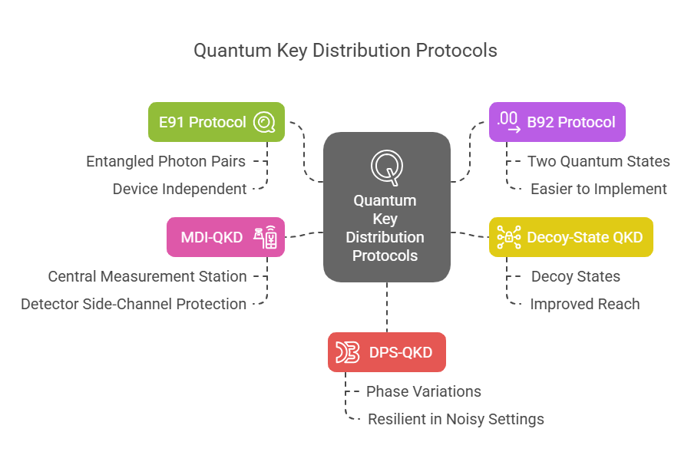

Table 3: QKD Protocol Comparison
Protocol | Key Idea | Security Mechanism | Advantage | Challenges
BB84 | Polarization encoding | No-cloning, measurement disturbance | Simple, proven, widely studied | Detector side-channel vulnerabilities
E91 | Entangled photon pairs | Bell’s theorem, quantum correlations | Source independence, high theoretical security | Requires entanglement sources
B92 | Two non-orthogonal states | Quantum state discrimination | Simpler design | Higher vulnerability to some attacks
Decoy-State | Signal + decoy pulse intensities | Detection of PNS attacks | Enhanced security with imperfect photon sources | More complex hardware control
MDI-QKD | Centralized measurement | Secure even with untrusted detectors | Immunity to detector-based attacks | More complicated synchronization
DPS-QKD | Phase difference of pulse trains | Phase-based encoding | Robust in fibre, longer distances possible | Complex implementation

Table 4: Key Features for the QKD Algorithms
Protocol | Year / Inventors | Approach | Notable Features
BB84 | 1984, Bennett & Brassard | Prepare-and-measure (single-photon polarization | First QKD protocol; uses two bases; foundational.
E91 | 1991, Ekert | Entanglement-based | Uses entangled pairs and Bell’s theorem; intrinsic randomness.
B92 | 1992, Bennett | Prepare-and-measure | Two non-orthogonal states; simpler but lower efficiency.
SARG04 | 2004, Scarani et al. | Variant of BB84 | Robust against certain photon-number attacks.
CV-QKD | 2002, Grosshans & Grangier | Continuous variables (Gaussian modulation) | Uses coherent pulses and homodyne detection; compatible with telecom hardware.
MDI-QKD | 2012, Lo et al. | Time-reversed entanglement | Removes trust on detectors; middle node untrusted.
TF-QKD | 2018, Lucamarini et al. | Twin-field interference | Overcomes standard rate-distance limit; multi-km links.
DI-QKD | Mid-2000s (principle) | Fully device-independent | Security proven by Bell violation; not yet practical.

Implementation Strategies & Technologies:
Implementing quantum cryptography in real-world environments requires a range of specialized technologies. At the core of any QKD system are photon sources and detectors. These devices must be capable of generating and detecting single photons or entangled photon pairs with high precision and minimal noise. Avalanche photodiodes and superconducting nanowire single-photon detectors are among the most commonly used technologies for this purpose. In CV-QKD, modulated lasers and fast homodyne detectors are used. Detector imperfections (efficiency, dark counts) limit performance and require careful calibration.
The transmission of quantum states is typically achieved through fibre optic cables or free-space optical links. While fibre is convenient for metropolitan networks, it suffers from signal attenuation over long distances. To overcome this limitation, some systems use satellite-based communication, where photons are transmitted through the vacuum of space to significantly reduce loss.
Key management and integration with classical networks is another critical component of quantum cryptography. A Key Management System (KMS) collects keys from QKD links and provides them to encryption applications. Quantum networks require Quantum Management Systems (QMS) to coordinate key exchanges and manage encryption infrastructure. In addition, there is ongoing work in developing protocols and standards that allow QKD to be integrated into existing communication architectures.
Commercial interest in quantum cryptography has grown significantly, with companies such as ID Quantique, Toshiba, and Quintessence Labs and many more are offering ready-to-deploy QKD systems.
In parallel, standardization efforts led by organizations like ETSI, ITU, ISO, and IEEE are working to define interoperability and security benchmarks, facilitating broader adoption across industries.

Table 5: Commercial QKD Technologies
Company | Country | QKD Product/Service | Notable Deployment or Feature
ID Quantique | Switzerland | Clavis/Cerberis (fiber QKD units); Clavis3, XG Series (2021–22) | Deployed since 2007; secured Geneva elections 2007; world’s first QKD network; ETSI standards lead.
Toshiba | Japan | Tokyo QKD (CV-QKD); high-rate BB84 systems | First 100 km QKD (2003) and >10 Mbit/s key rate (2017).
QuantumCTek (Qasky) | China | Pioneering China’s QKD backbone; lab to long-distance QKD | Led Chinese Beijing-Shanghai QKD network (2008) and satellite projects with Pan Jianwei.
QuintessenceLabs | Australia | qRNG RNG devices; qOptica (CV-QKD) | Key management & encryption platform (TSF); worked with Australian govt (AUS e-health pilot).
MagiQ Tech | USA | Fiber & free-space QKD systems (now Orbis Quantum) | Early U.S. QKD vendor; collaborated with NASA and DoD on QKD.
SK Telecom | Korea | QKD network services (uses IDQ hardware) | First QKD-as-a-Service (QaaS) with Equinix data center (2023).
Nu Quantum | UK | Single-photon sources (chip-based); entangled photon QKD plans | Develops integrated photonic QKD platforms; part of UK’s quantum networks initiative.

Key Players in this Industry:
Academic and Government Research
Quantum cryptography is advanced by researchers worldwide. Notable academic centres include the University of Geneva (N. Gisin’s group), Centre for Quantum Technologies (CQT, National University of Singapore), University of Science and Technology of China (Pan Jianwei’s group), and Oxford University (Artur Ekert, David Weir et al.). For example, CQT explicitly focuses on both QKD and post-quantum crypto, “sending quantum keys via fibre and satellite” to build Singapore’s future secure network. China’s USTC led the space QKD breakthroughs (Micius, Jinan-1) mentioned above. North American efforts (NIST, MIT, Caltech) often emphasize security proofs and integration with classical networks. Governments and defence agencies (e.g. DARPA, EU’s Quantum Flagship, UK’s quantum program) sponsor QKD research. International collaboration is growing: organizations like NIST and ETSI are jointly developing standards and certification for “quantum-safe” cryptography.
Industry and Commercial Entities
On the industrial side, the leading companies (as of 2024) include ID Quantique (Switzerland), Toshiba/NICT (Japan), QuintessenceLabs (Australia), MagiQ/Orbis (USA), and QuantumCTek (China). These firms offer QKD hardware, key management, and related services. Telecom companies (e.g. SK Telecom, China Mobile, NTT, KT Corporation) and national research labs also build custom QKD networks. Startups like QNu Labs (India), KETS Quantum (Canada/UK), and Nu Quantum (UK) are emerging with specialized quantum-secure products. According to market analysis, the QKD market is led by “globally established players” including the above. For example, Taiwan’s Chunghwa Telecom and Germany’s Deutsche Telekom have run QKD trials. Several banks (HSBC, JP Morgan) have partnered with QKD vendors to secure inter-data-centre links.
Government and standards bodies are also key players. The Chinese government has invested heavily and plans global QKD via satellites by 2027. The EU’s Quantum Communication Infrastructure (QCI) project aims to link member states with QKD by 2027. In the US, NIST has focused on post-quantum algorithms but collaborates on QKD. All these efforts involve academia and industry partnerships. In summary, the ecosystem is a mix of research labs, telecom operators, defence/military agencies, and startups, working together to commercialize quantum cryptography.

Real World Applications:
Quantum cryptography is transitioning from theoretical exploration to practical deployment. One of the most ambitious real-world implementations is China's Micius satellite, which has successfully demonstrated QKD over distances exceeding 1,000 kms. By transmitting entangled photons between ground stations, Micius has achieved quantum-secured communication on a global scale, paving the way for satellite-based quantum networks.
In the financial sector, banks in Switzerland, Austria, and South Korea have adopted QKD to secure sensitive transactions and internal communications. These deployments illustrate the growing recognition of quantum cryptography as a viable tool for protecting high-value data.
Metropolitan quantum networks have also been developed in cities like Geneva, Tokyo, and Beijing. These networks use fibre optics to connect critical infrastructure, including government buildings, research institutions, and corporate offices. The implementation of QKD in these networks demonstrates its effectiveness in enhancing the security of urban communication infrastructures.
Table 6: Real World Applications
Application | Example | Outcome
Swiss Elections | ID Quantique QKD link (Geneva 2007) | Secure encryption keys distributed during voting; system still in operation.
Financial Trading | HSBC and JP Morgan trials (2023) | QKD-secured FX and blockchain data links; demonstrated finance interest.
Satellite Network | China’s Micius & Jinan-1 satellites | QKD between continents (Beijing–Vienna, Beijing–Stellenbosch); real-time global QKD achieved.
Telecom Backbone | SK Telecom 5G network QKD (2023) | QKD devices installed on backbone; commercial QaaS launched with Equinix.
Government Network | Chinese QKD backbone (Beijing-Shanghai) | Hundreds of km of quantum-secured metro links for ministries and telecom.

Challenges:
Despite its promise, quantum cryptography faces several practical challenges that must be addressed for widespread adoption. One major limitation is distance. Optical fibre, while effective for short-range communication, experiences significant signal loss over long distances. Without quantum repeaters, which are still in development, the effective range of terrestrial QKD is limited to around 100–200 kms.
Device imperfections present another significant challenge. In real-world systems, hardware is subject to flaws and limitations that can introduce security vulnerabilities. Attacks exploiting these imperfections, such as detector blinding or side-channel attacks, have demonstrated that theoretical security must be complemented with rigorous device testing and countermeasures.
Cost and scalability also remain barriers to broader deployment. The specialized equipment required for QKD is expensive and often requires highly controlled environments. Furthermore, the generation of secure keys at high speeds over long distances is still an area of active research, limiting the practicality of QKD for high-throughput communication systems.
Future Directions and Potential Breakthroughs:
Looking ahead, research in quantum cryptography is focused on overcoming current limitations and expanding its capabilities. One promising avenue is the development of quantum repeaters, which will allow quantum signals to be transmitted over much longer distances by preserving entanglement across multiple network segments.
The concept of a global quantum internet, where entangled nodes communicate securely across vast distances, is also gaining traction. This would enable not only secure communication but also distributed quantum computing and sensing applications.
Another complementary development is post-quantum cryptography (PQC), which involves classical algorithms that are resistant to quantum attacks. While QKD and PQC differ in their approach, they are not mutually exclusive and may coexist in hybrid security systems.
Standardization and regulation will also play a critical role in the future of quantum cryptography. International collaboration is essential to establish trust, ensure interoperability, and develop the legal and ethical frameworks needed to support a secure quantum infrastructure.

Conclusion:
Quantum cryptography marks a paradigm shift in the field of information security. By leveraging the inherent properties of quantum mechanics, it provides a level of security that is fundamentally different from classical approaches. While significant challenges remain in terms of cost, scalability, and practical implementation, ongoing advances in technology and standardization are steadily paving the way for its integration into mainstream communication systems. As quantum threats become more tangible, quantum cryptography is poised to become an essential component of global cybersecurity strategies.
Tables: The above tables compare QKD protocols , QKD security mechanisms , QKD features , QKD real world applications , a comparative analysis between classical and quantum cryptography and highlights commercial QKD solutions.

References and Citations:
- Bennett, C. H., & Brassard, G. (1984). Quantum cryptography: Public key distribution and coin tossing.
- Ekert, A. K. (1991). Quantum cryptography based on Bell’s theorem.
- Gisin, N., Ribordy, G., Tittel, W., & Zbinden, H. (2002). Quantum cryptography.
- Scarani, V., Bechmann-Pasquinucci, H., Cerf, N. J., et al. (2009). The security of practical quantum key distribution.
- Pirandola, S., et al. (2020). Advances in quantum cryptography.
- ID Quantique: https://www.idquantique.com
- ETSI Quantum Safe Cryptography: https://www.etsi.org/technologies/quantum-safe-cryptography
- A Quick Guide to Quantum Communication

- Quantum Cryptography: A Review of the Literature - NHSJS

- Update: Chinese-led team achieves world's first 10,000-km quantum-secured communication -Xinhua

- A Quick Guide to Quantum Communication

- Quantum Key Distribution | TOSHIBA DIGITAL SOLUTIONS CORPORATION

